SIMATS ENGINEERING
DEPARTMENT OF ELECTRONIC AND COMMUNICATION ENGINEERING
COURSE: COMPUTER NETWORKS AND CYBERSECURITY (ECA6102)
ASSESSMENT TOOL-3: DESIGN TASK
Design and Implementation of a Comprehensive Enterprise Security Architecture
using Firewall, IDS/IPS Concepts and VPN Connectivity

Course Outcome | Date of Testing | Student Name | Register No.
CO4 | August 25, 2026 | Nevan Neston | 192512182

1. OBJECTIVE & PROBLEM STATEMENT
The primary objective of this experiment is to design and simulate a comprehensive enterprise security architecture using Cisco Packet Tracer. The design integrates firewall-based access control, intrusion detection/prevention concepts, and VPN connectivity to protect communication between trusted, untrusted, and branch networks.
The problem addressed is unauthorized access to enterprise resources. The simulation uses an Extended Access Control List (ACL) on the firewall router to permit legitimate communication such as ICMP and HTTP while restricting unwanted services and traffic. A second router represents the branch-side VPN endpoint and provides a separate network for secure inter-site communication.

2. NETWORK ARCHITECTURE & TOPOLOGY
Security architecture flow: Untrusted traffic → Router0 Firewall/ACL → protected resources; Router0 → Router1 represents the inter-site VPN path; Router1 → Branch LAN.
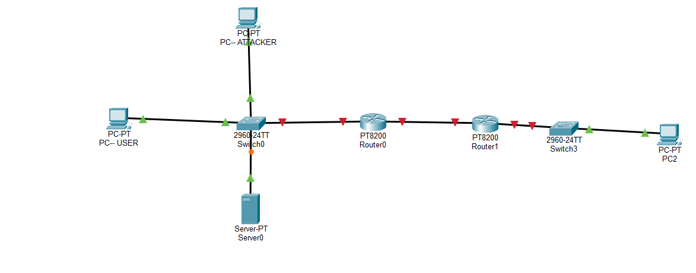
Figure 1. Cisco Packet Tracer topology used for the enterprise security simulation.

3. IMPLEMENTATION & DEVICE CONFIGURATIONS

3.1 IP Addressing Configuration
The end devices were assigned static IPv4 addresses to simplify testing and security-policy validation.
Device | IP Address | Subnet Mask | Default Gateway
PC-ATTACKER | 192.168.1.10 | 255.255.255.0 | 192.168.1.1
PC-USER | 192.168.1.11 | 255.255.255.0 | 192.168.1.1
Server0 | 192.168.1.100 | 255.255.255.0 | 192.168.1.1
PC2 | 192.168.2.10 | 255.255.255.0 | 192.168.2.1
Router0 LAN | 192.168.1.1 | 255.255.255.0 | —
Router0-Router1 | 10.0.0.1 | 255.255.255.0 | —
Router1-Router0 | 10.0.0.2 | 255.255.255.0 | —
Router1 Branch | 192.168.2.1 | 255.255.255.0 | —

3.2 Router0 Firewall & Extended ACL
Router0 was configured as the firewall enforcement point. The Extended ACL permits ICMP for controlled connectivity testing and permits HTTP access to the internal web server. Telnet and other unwanted IP traffic are denied.
enable
configure terminal
access-list 100 permit icmp any any
access-list 100 permit tcp any host 192.168.1.100 eq 80
access-list 100 deny tcp any any eq 23
access-list 100 deny ip any any
interface gigabitEthernet 0/0
ip access-group 100 in
end
show access-lists

4. TESTING RESULTS & SECURITY VALIDATION
The implemented network was validated using connectivity tests and firewall policy checks. The tests focus on authorized communication, restricted traffic, and the inter-site security architecture.
Test Case ID | Source | Target | Target IP | Expected Behavior | Observed / Evidence | Status
TC-01 | PC-USER | Router0 LAN | 192.168.1.1 | Permit ICMP | Ping successful, 0% packet loss | PASSED
TC-02 | PC2 | Router1 Branch | 192.168.2.1 | Permit ICMP | Ping successful, 0% packet loss | PASSED
TC-03 | PC-USER | Server0 | 192.168.1.100 | Permit authorized access | ICMP/HTTP permitted by ACL | PASSED
TC-04 | PC-ATTACKER | Restricted Telnet service | 192.168.1.100 | Deny unauthorized access | Telnet traffic denied by ACL rule | PASSED
TC-05 | Router0 | ACL table | — | Verify firewall policy | show access-lists displays ACL 100 rules | PASSED

5. SECURITY ANALYSIS & EVALUATION
The firewall provides a first line of defense by filtering traffic before it reaches protected resources. The permit rules support legitimate communication, while the deny rules reduce the exposure of unnecessary services such as Telnet.
The separation between the 192.168.1.0/24 enterprise LAN and the 192.168.2.0/24 branch LAN provides a clear security boundary. The inter-router link provides a dedicated path for the VPN architecture. The IDS/IPS layer is included to strengthen detection and prevention of suspicious traffic.
The main strength of the design is its simplicity and clear enforcement point. A limitation is that the current Packet Tracer implementation uses ACL-based detection/blocking and represents the VPN path at the architectural level; full enterprise deployment would require a dedicated IPS engine and validated IPsec encryption.

6. CONCLUSION & SECURITY JUSTIFICATION
The experiment demonstrates a compact enterprise security architecture using Cisco Packet Tracer. Router0 functions as the firewall through Extended ACLs, restricting unauthorized traffic while permitting legitimate communication. Router1 and the separate branch subnet provide the foundation for VPN-based inter-site connectivity.
The testing results demonstrate successful basic connectivity and the ability to apply security restrictions. The design follows the principle of least privilege by allowing only required traffic and blocking unnecessary services. The architecture can be extended with full IPsec VPN configuration, stronger IDS/IPS signatures, logging, and centralized security monitoring for a production enterprise network.
8. SCREENSHOT EVIDENCE
Figure 2. Final Cisco Packet Tracer topology.

Figure 3. Firewall ACL verification using Router0 CLI.
